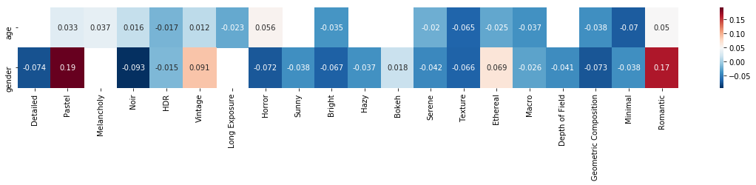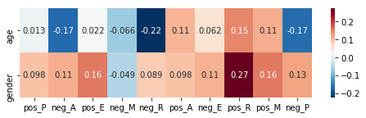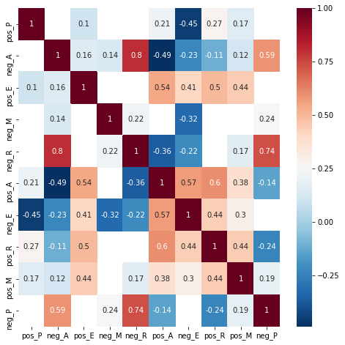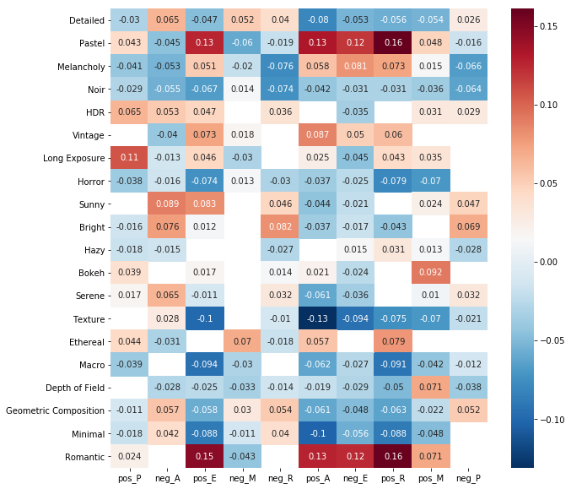

HDR：高动态范围成像（HDRI）是一种高动态范围（HDR）技术，用于成像和摄影，以再现比标准数字成像或摄影技术更大的动态光度范围。 目的是提供与人类视觉系统相似的亮度范围。

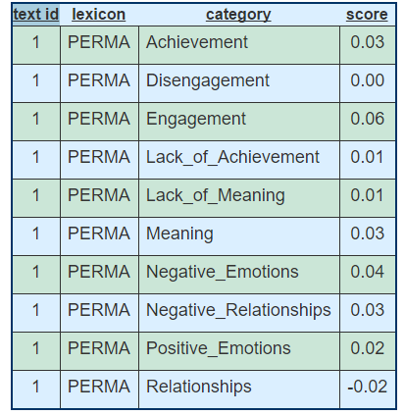

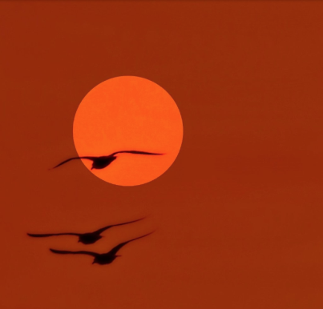

Label:0 <https://www.flickr.com/groups/details_all_kinds/>

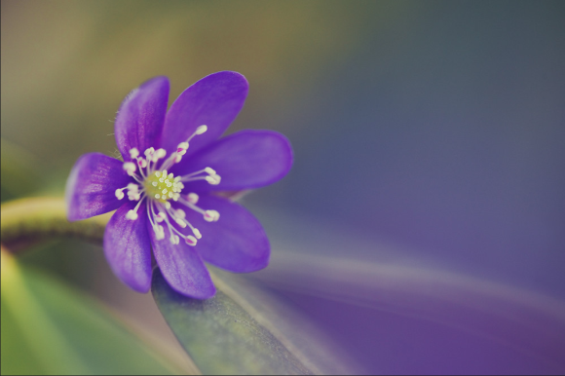

Label:1 <https://www.flickr.com/groups/pastelanddreamy/>

Pastel means a color or hue that is *soft*, *delicate*, *pale*, light, muted, subtle, **as if the true color has been mixed with white to lighten it.**

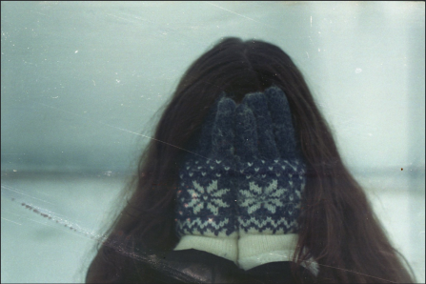

Label:2 <https://www.flickr.com/groups/melancholy/>

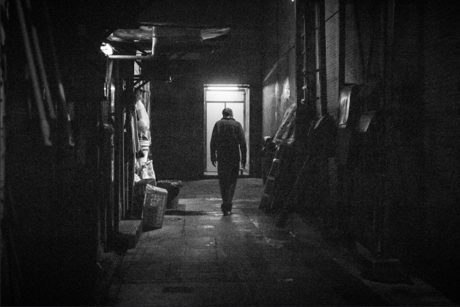

.) Your black and white, color or sepia photographs that have a film noir sensibility.   
2.) Photographs from any of the Noir City Film Festivals that have been held in San Francisco, California.   
3.) Photographs from other film noir related festivals.   
4.) Publicity and production photographs from amateur noir themed short films.   
5.) Photographs from film noir related photography exhibitions.   
6.) Photographs of staged recreations of iconic film noir imagery.   
7.) Sets of photographs that tell a story.   
8.) Photographs from film noir themed parties.   
9.) Heartfelt observations about the photographs that people choose to share with this group.   
10.) News about film noir related events may be posted in the discussion forum.

Label-Noir:3 <https://www.flickr.com/groups/noircity/>

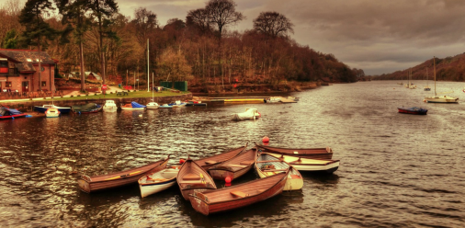

包含大量的人物和街道，几乎都是黑白色调。

Label:4 <https://www.flickr.com/groups/qualityhdr/>

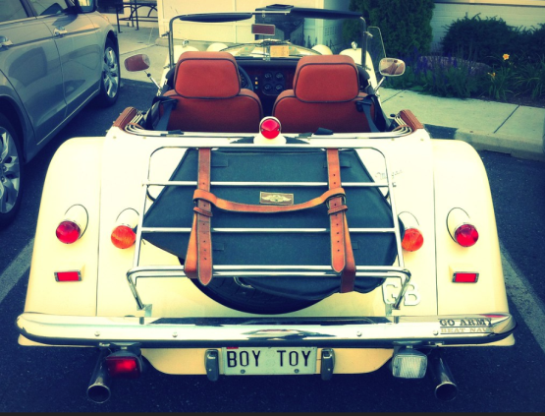

Label5：vintage <https://www.flickr.com/groups/vintagefeelings/>

主要特征是复古、旧式

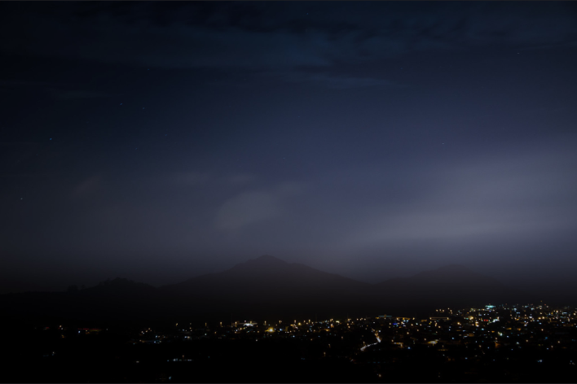

**"The rendering of light, time and/or motion in photography."**  
  
This means that you should only submit images where there is visible motion (something has motion blur, star trails, light painting, etc) or there was a significantly long exposure required of a still scene (>=1 second for a still scene).  
In other words, if the photo you wish to submit is under 1 second of exposure time, it needs to show something is visibly moving in the exposure.  
Examples of whats allowed:  
1/60th photo of a car racing  
1/5th of a waterfall  
1 second exposure of a ballerina performing a pirouette  
30 second exposure of a stream

label6:long exposure<https://www.flickr.com/groups/longexposure/>

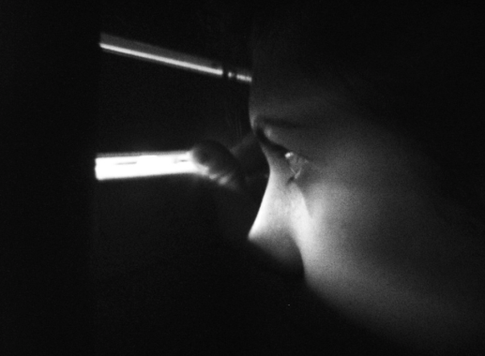

The scariest pics you can find.... Put your bloodiest, ghastliest, freakiest snaps in the Horror Pool of Blood!!! Bwa-ha-ha-haaaaaaa!!!

Label:7Horror <https://www.flickr.com/groups/horror/>

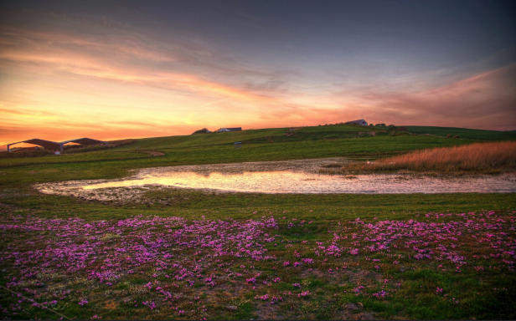

Add any pictures that include the sun, sunrise, sunset, any genre aswell. Everyone loves sunlit portraits! Lets just freeze the moment and keep it sunny forever in this group! =D

群組規則

1. Only photos which contain the sun or an effect of the sun eg. orange sky  
2. Only photos that are suitable for all ages

Label:8Sunny <https://www.flickr.com/groups/sun_sun_and_more_sun/>

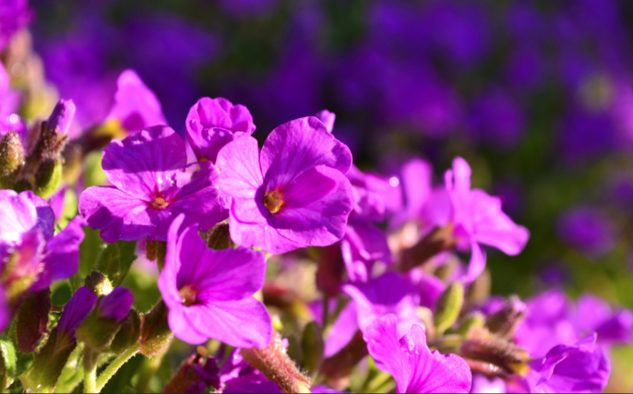

**bold, bright, crazy, dreamy, energetic, happy, hip, intense, loud, manic, silly, strong, vibrant, and/or psychedelic colors. The BRIGHTER THE BETTER. ...DULL PICS WILL BE DELETED!**

Label9:Bright <https://www.flickr.com/groups/colour_mania/>

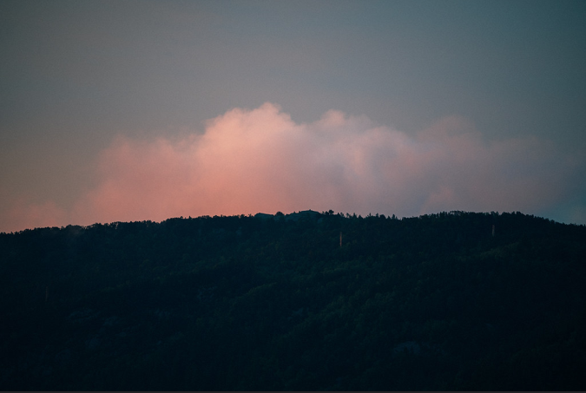

This is for atmospheric shots which are misty or foggy, or hazy from a heat haze, or smokey. It could be smoke from a bonfire in a park or woodland, for example. Shots could be urban or rural, even interior. A snowstorm could also be possible.

Label10:hazy <https://www.flickr.com/groups/misty/>

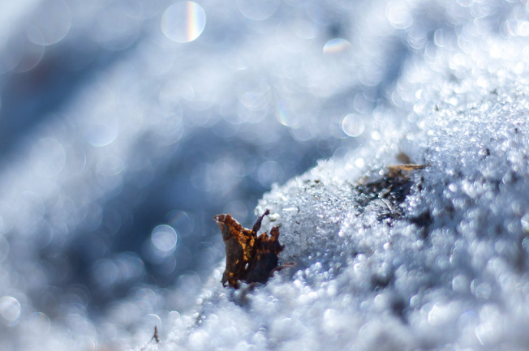

The area that is out of focus is called the bokeh.

Label11：Bokeh<https://www.flickr.com/groups/bokeh-and-bokeh/>

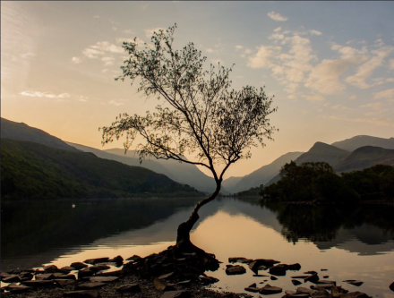

Welcome to Serene! Here you can post your most **tranquil, calming, soothing images**– pictures of **peaceful places, relaxing views, placid corners,** and images with **soft, cool, pastel colors.**

label12：<https://www.flickr.com/groups/serene/>

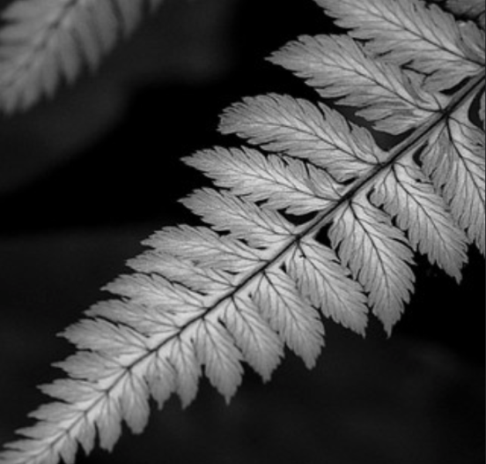

label13：<https://www.flickr.com/groups/texture/>

Texture: Pronunciation Key (tkschr)   
1. The distinctive physical composition or structure of something, especially with respect to the size, shape, and arrangement of its parts: the texture of sandy soil; the texture of cooked fish.  
2. The appearance and feel of a surface: the smooth texture of soap.   
3. The characteristic appearance of a surface having a tactile quality

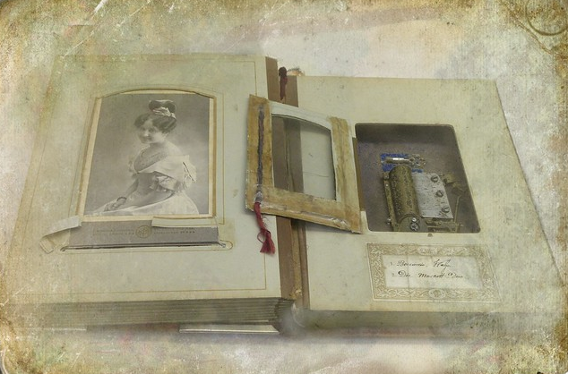

This pool is about delicate and ethereal images. The images may be translucent or high key, The objects may be wispy or fragile, or dreamlike and tenuous. But the composition must be subtle and refined. No garishness is welcome here. Feel free to submit, although I suggest you check other images in this pool for an indication of quality!   
If your image has not been accepted to this pool after your submission, there may be one or more of the following reasons involved:  
  
1. The image lacks an ethereal quality. This is a very subjective consideration, but is paramount nonetheless.  
2. The image is not of sufficient artistic quality. I value high quality works and will accept them more readily.  
3. The composition is excessively bland or banal.

label14:<https://www.flickr.com/groups/ethereal/>

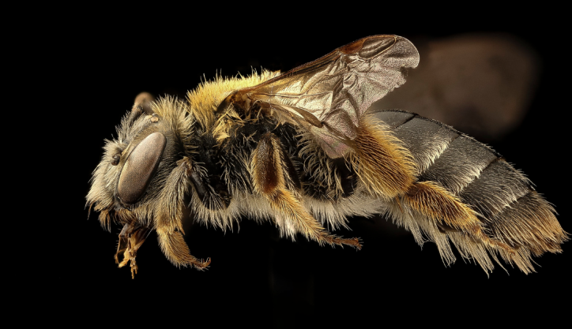

Images must be true MACRO or at least VERY close-up images with **the majority of the frame showing the focal point in macro.** Please note that using a macro lens or the macro mode on a camera may NOT produce an image that is a true macro.  
  
Close-Up Photography is where the reproduction ratio is from 1:10 to 1:2 - ie from 1/10th life-size to one half life-size.   
  
Macro Photography is where the reproduction ratio is from 1:1 to 10:1 - ie from life-size to ten times life-size.   
  
And, for the record, Micro Photography is where the reproduction ratio is ~5:1 or greater - ie greater than about 5x life-size.  
  
NEW!!! Let's get Closer! This is a dedicated macro photography group and the intention is for you to get closer and closer to your subject. What makes a true macro? Avoiding the technicalities across sensor and film sizes, for the purposes of this group, "macro" is something that is around 35mm (~1.38in) or smaller that fills the frame.   
  
We recommend this article in Wikipedia for a detailed description of "true macro". Here is one comment: "the lens is typically optimized to focus sharply on a small area approaching the size of the film frame." Thus, showing a whole animal or most of an animal/person/object/flower may not be a true macro but an image shot with a macro lens.  
  
[en.wikipedia.org/wiki/Macro_photography](http://en.wikipedia.org/wiki/Macro_photography)

label15Macro：<https://www.flickr.com/groups/closer_and_closer/>

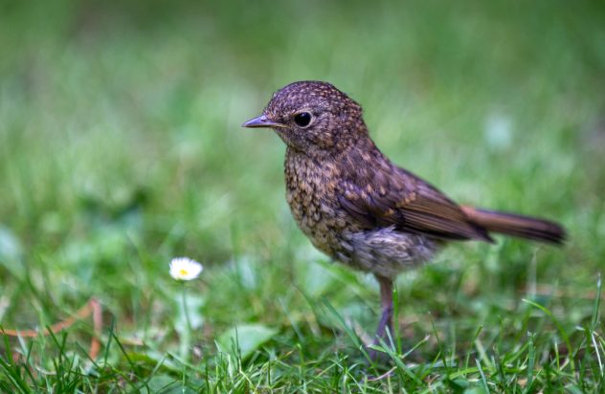

We want to see photos that capture the drama through **Depth of Field**.  
In our pool, the images should have a **significant DOF**. It may be shallow or wider. No limits here. But some area/region or some subjects should be out-of-focus at least.  
Subjects left out-of-focus and/or in-focus should create the meaning.  
Depth of Field is; the area, range between the nearest and the furthest point in focus.  
For more details, please see [en.wikipedia.org/wiki/Depth_of_field](http://en.wikipedia.org/wiki/Depth_of_field)

Label16depth of field：<https://www.flickr.com/groups/dofield/>

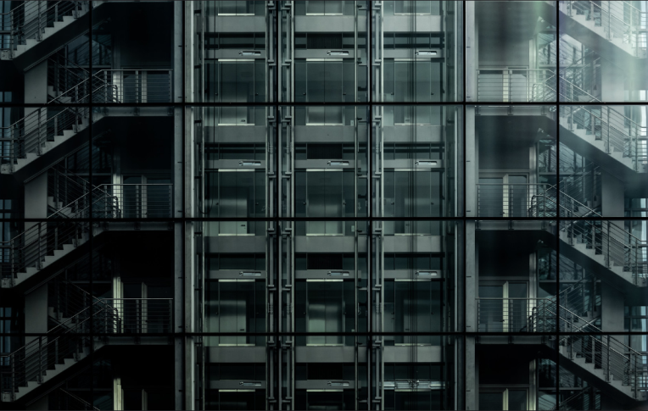

Circles, triangles, rectangles, symmetric objects, repeated patterns, objects with golden ratio... geometric beauty always attracts us for some reason.

Label 17 geometric：<https://www.flickr.com/groups/geometric/>

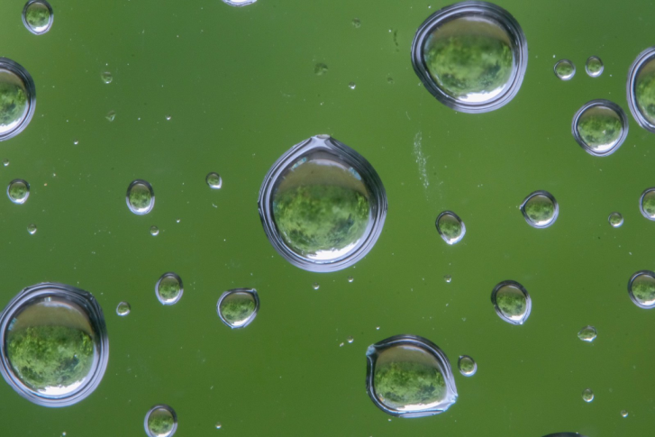

Label18：<https://www.flickr.com/groups/minimalist-art/>

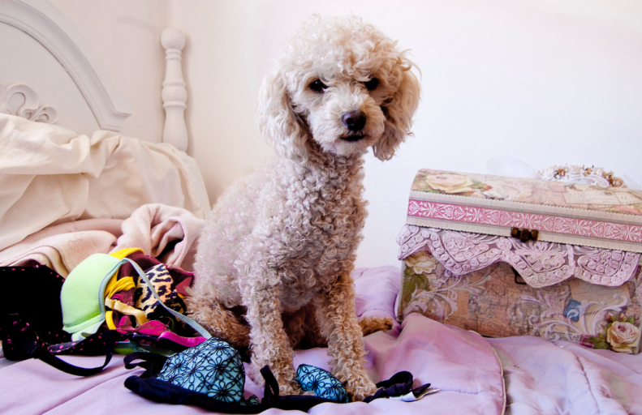

Label19：romantic [https://www.flickr .com/groups/romanticimages/](https://www.flickr.com/groups/romanticimages/)

Detail：尽可能的显示对象的细节

Pastel：是指柔和，细腻，苍白，轻盈，柔和，微妙的颜色或色调，好像真正的颜色与白色混合使其变亮。

melancholy：[Depression (mood)](https://en.wikipedia.org/wiki/Depression_(mood)), a state of low mood, also known as melancholy

Long Exposure：1/60速度赛车的照片

瀑布流速的1/5

练习旋转的芭蕾舞演员1秒曝光

流30秒曝光

Ethereal：这是关于精致和空灵的图像。 图像可以是半透明的或高调的，物体可以是纤细的或脆弱的，或者是梦幻般的和脆弱的。 但构图必须细微而精致。 这里不欢迎花哨。 随意提交，虽然我建议您检查此池中的其他图像以获得质量指示！

如果在提交后您的图像未被此池接受，则可能存在以下一个或多个原因：

1.图像缺乏空灵的品质。 这是一个非常主观的考虑因素，但仍然是最重要的。

2.图像的艺术品质不够。 我重视高质量的作品，并会更容易接受它们。

这种成分过于平淡或平庸。

This pool is about delicate and ethereal images. The images may be translucent or high key, The objects may be wispy or fragile, or dreamlike and tenuous. But the composition must be subtle and refined. No garishness is welcome here. Feel free to submit, although I suggest you check other images in this pool for an indication of quality!

If your image has not been accepted to this pool after your submission, there may be one or more of the following reasons involved:

1. The image lacks an ethereal quality. This is a very subjective consideration, but is paramount nonetheless.

2. The image is not of sufficient artistic quality. I value high quality works and will accept them more readily.

3. The composition is excessively bland or banal

Macro：. 我们在维基百科中推荐这篇文章，详细描述“真正的宏”。以下是一条评论：“镜头通常经过优化，可以在接近胶卷画幅大小的小区域上进行精确对焦。”因此，显示整个动物或大多数动物/人/物体/花可能不是真正的宏，而是用微距镜头拍摄的图像。

**Macro photography** (or **photomacrography**[[1]](https://en.wikipedia.org/wiki/Macro_photography#cite_note-1)[[2]](https://en.wikipedia.org/wiki/Macro_photography#cite_note-2) or **macrography**,[[3]](https://en.wikipedia.org/wiki/Macro_photography#cite_note-saxby-3) and sometimes **macrophotography**[[4]](https://en.wikipedia.org/wiki/Macro_photography#cite_note-4)), is extreme [close-up](https://en.wikipedia.org/wiki/Close-up) [photography](https://en.wikipedia.org/wiki/Photography), usually of very small subjects and living organisms like insects, in which the size of the subject in the photograph is greater than life size (though *macrophotography* technically refers to the art of making very large photographs).[[3]](https://en.wikipedia.org/wiki/Macro_photography#cite_note-saxby-3)[[5]](https://en.wikipedia.org/wiki/Macro_photography#cite_note-5) By the original definition, a macro photograph is one in which the size of the subject on the [negative](https://en.wikipedia.org/wiki/Negative_(photography)) or [image sensor](https://en.wikipedia.org/wiki/Image_sensor) is life size or greater.[[6]](https://en.wikipedia.org/wiki/Macro_photography#cite_note-Marom-6) However, in some uses it refers to a finished photograph of a subject at greater than life size.[[7]](https://en.wikipedia.org/wiki/Macro_photography#cite_note-photography.com_1-7)

Horror：

你能找到的最恐怖的照片......把你最血腥，最可怕，最怪异的照片放进恐怖池中！BWA，哈，哈，haaaaaaa！恐怖照片。

Bright：

大胆，明亮，疯狂，梦幻，充满活力，快乐，时尚，激烈，响亮，躁狂，愚蠢，强烈，充满活力，和/或迷幻色彩。 更棒的是。 ...... DULL PICS将被删除！

Geometric：

圆形，三角形，矩形，对称物体，重复图案，黄金比例的物体......几何美感总是因某种原因吸引我们。

Sunny：

添加任何包含太阳，日出，日落，任何类型的图片。 每个人都喜欢阳光照射的肖像！ 让我们冻结这一刻，让这群人永远保持阳光！

Texture：

1.某物的独特物理成分或结构，特别是其部分的大小，形状和排列：沙质土的质地; 熟鱼的质地。

2.表面的外观和感觉：肥皂的光滑质地。

3.具有触觉质量的表面的特征外观

Bokeh：https://en.wikipedia.org/wiki/Bokeh

In [photography](https://en.wikipedia.org/wiki/Photography), **bokeh** is the aesthetic quality of the blur produced in the [out-of-focus](https://en.wikipedia.org/wiki/Defocus_aberration) parts of an image produced by a [lens](https://en.wikipedia.org/wiki/Lens_(optics)).[[2]](https://en.wikipedia.org/wiki/Bokeh#cite_note-Gerry_Kopelow_1998_118–119-2)[[3]](https://en.wikipedia.org/wiki/Bokeh#cite_note-3)[[4]](https://en.wikipedia.org/wiki/Bokeh#cite_note-4) Bokeh has been defined as "the way the lens renders out-of-focus points of light".[[5]](https://en.wikipedia.org/wiki/Bokeh#cite_note-5)

在摄影中，散景是由镜头产生的图像的离焦部分产生的模糊的美学质量。散景被定义为“透镜渲染失焦光点的方式”。

Depth of Field：<https://en.wikipedia.org/wiki/Depth_of_field>

景深（DOF）是在图像中处于可接受的清晰焦点的最近和最远物体之间的距离。

Minimal：https://en.wikipedia.org/wiki/Minimalism_(visual_arts)

其中的工作旨在通过消除所有非必要的形式，特征或概念来揭示主题的本质，要素或身份。